Scecina Memorial High School

Course Directory

2026-2027
Class of 2030

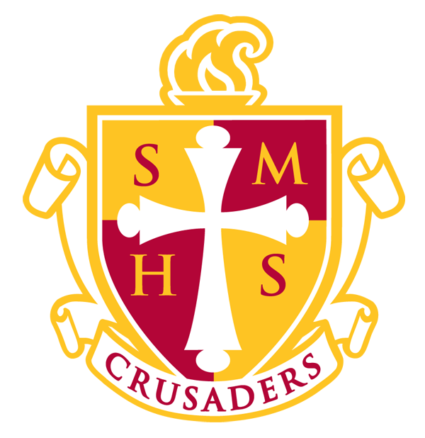

MISSION STATEMENT

Scecina Memorial High School, established by the Archbishop of Indianapolis,

is a co-educational Catholic college and life preparatory school that

motivates our diverse and gifted community of students to attain

educational excellence, be lifelong learners, and live as servant leaders

in the inspiring footsteps of Father Thomas Scecina.

5000 Nowland Ave • Indianapolis, IN 46201

Phone: 317.356.6377 • Fax: 317.322.4287

Table of Contents

Administration and Counseling Department 4
Additional State Requirement for Graduation 7
Grade Point Average and Grading Scale 8
Course Credit Recovery 8
(W) and (DC) Indicators – Weighted Courses 8
Advanced Placement (AP) Courses 9
Career and Technical Education – CTE Courses 9
Business Education 9
Catholic Theology 10
Computer Science 10
English 11
Fine Arts: Visual Arts 12
Fine Arts: Drama 12
Fine Arts: Media 13
Fine Arts: Music 13
Health and Physical Education 14
Mathematics 15
Multidisciplinary 16
Science 17
Social Studies 19
World Languages 20

Administration and Counseling Department
Joe Therber………………………………………………………………………………....…………………President
Dr. Peg Dispenzieri.………………………………………………………………………………....……..Principal
Marca Budzenski.………………………………....Assistant Principal, Curriculum and Instruction
Doug Hadley………………………………………….……………Director of School Counseling, Seniors

Kalynn Huntoon………………………………..….School Counselor Grades 9-11 Last Name A - L

Kim Johnson………………………………….…….School Counselor Grades 9-11 Last Name M – Z

Jane Verbarg.......................................................................................................Registrar

Dear Parents and Students:

This course directory is an important part of the planning process for every student. The brief course descriptions will help you understand the class content, while the prerequisites are designed to ensure academic success of enrolled students to meet and exceed the established course competencies.

Navigating the complexities of a high school curriculum takes the input of many different people. Not only does the school strive to meet the needs and interests of the student and his or her parents but must also consider the requirements of the Indiana Department of Education, Cognia accreditation standards and guidance from the Office of Catholic Schools. Our heartfelt goal is always to provide students at Scecina Memorial High School the absolute best education possible to pursue their dreams and develop their God-given gifts.

We look forward to assisting you as you plan and prepare for your child’s future during the scheduling process.

All classes will be subject to availability. Parents and students will be notified if the course requested is not available. Course changes will be made only for the following reasons: (1) academic misplacement as determined by classroom teacher, division chair, and administration, (2) medical hardship, (3) to maintain enough credits in required classes, (4) fulfillment of graduation requirements.

Dr. Peg Dispenzieri

Principal
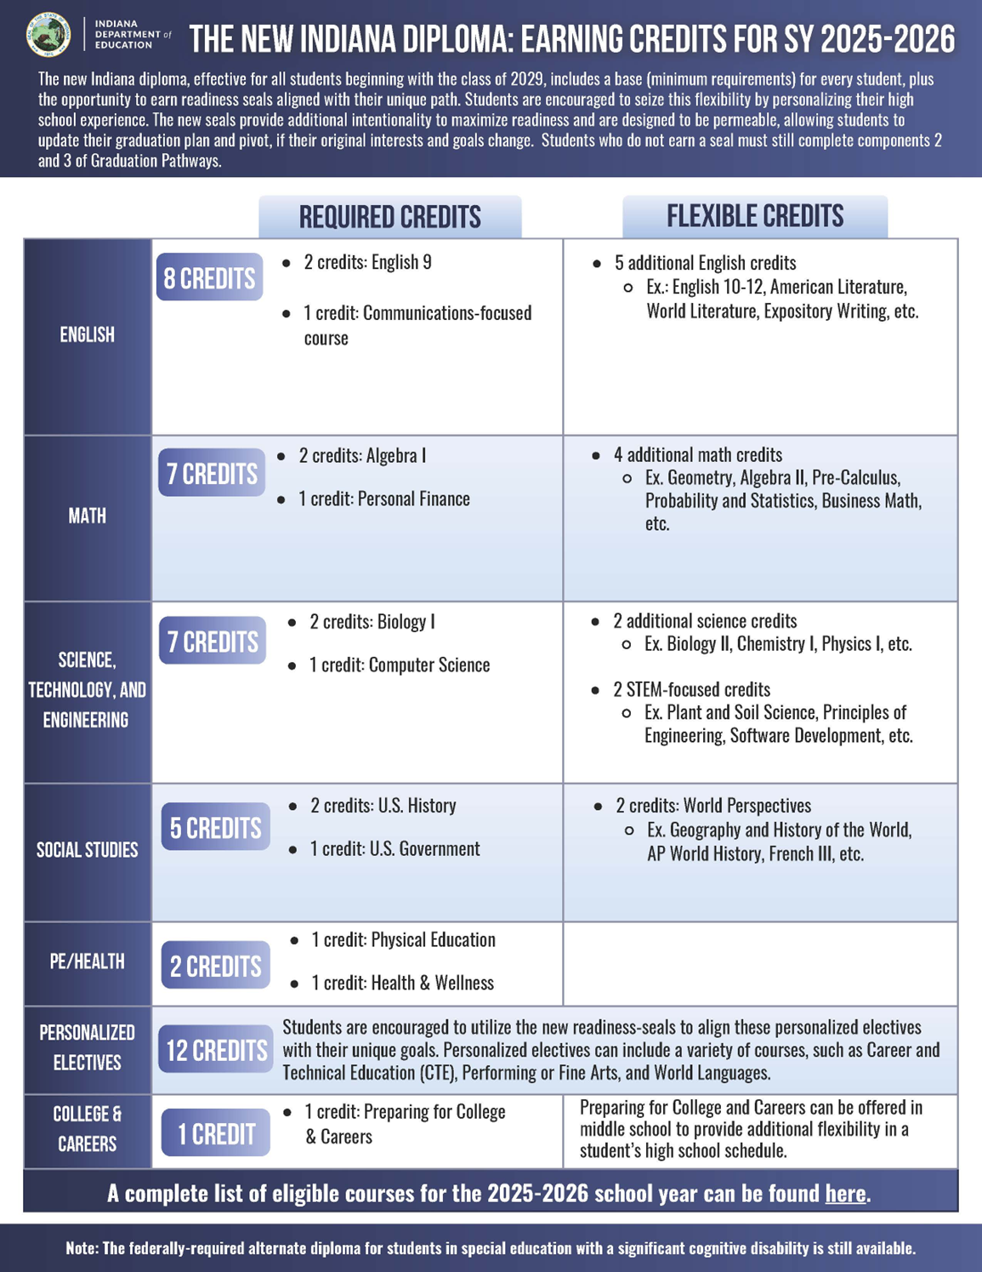
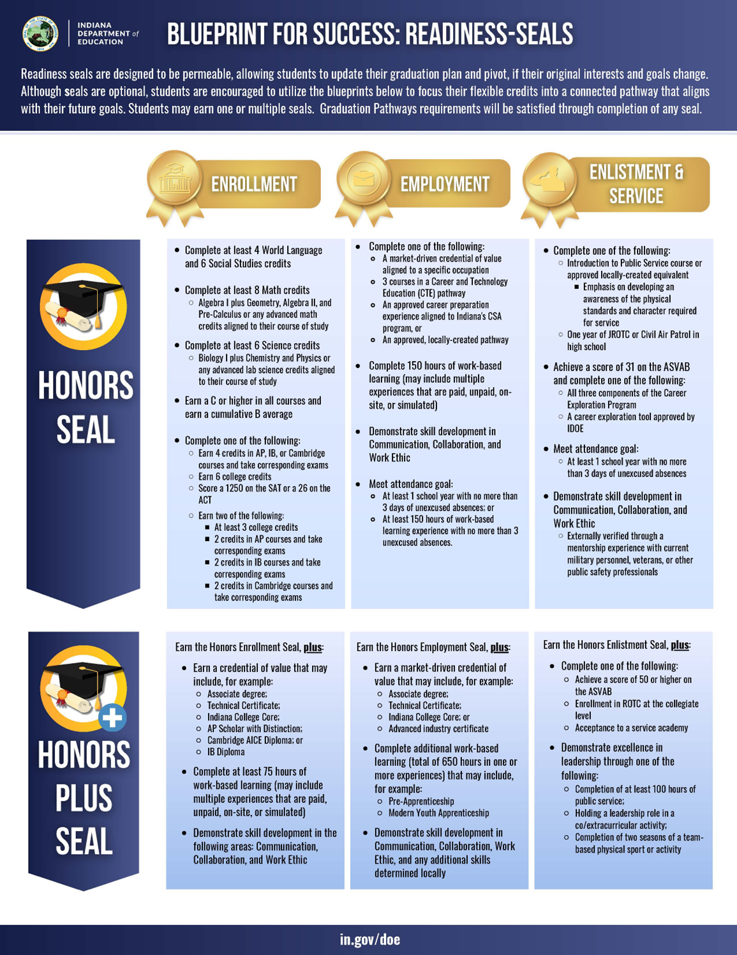
Graduation Pathways Checklist
How do I graduate from Scecina Memorial High School?

You must complete one requirement from each box!
Box 1 Diploma:
- Complete all diploma requirements- combination of required and elective classes
  - Academic Honors Diploma
  - Technical Honors Diploma
  - Core 40 Diploma
  - Indiana Diploma (Class of 2029 and beyond)
Box 2 Employability Skills
- Service Based Learning- Service Hours & Life Book (Capstone)
Box 3 Post Secondary Ready Competencies (you must complete at least one)
- Earn an Academic Honors Diploma
- Earn a Technical Honors Diploma
- Earn an Indiana Diploma Honors Seal (Class of 2029 and beyond)
- ACT: English 18 or Reading 22 AND Math 22 or Science 23
- SAT: Evidenced Based Reading and Writing: 480 AND math: 530
- ASVAB: 31 or higher and provide proof of enlistment
- CTE Concentrator
Arts, AV Tech and Comm: Radio/TV Broadcasting
- Prin of Broadcasting + Audio & Video Production + Mass Media Prod
Business Management and Admin: Business Administration
- Prin of Business Mgt + Mgt Fund or Marketing Fund + Account Fund
Finance: Accounting:
- Prin of Business Management + Accounting Fund + Adv Accounting
Information Technology: Computer Science:
- Prin of Comp Sci + Topics of CS + Computer Science
- AP (Advanced Placement) and/or Dual Credit (high school and college credit)
Must earn a C- average or higher in at least 3 courses
- Locally Created Pathway- Civic Arts
All Students in the Civic Arts Pathway must take Intro to Business or Principles of Business Management AND:
  - Art: 2D Art + 3D Art + Ad 2D Art or Ad 3D Art
  - Band: Beginning Band + Advanced Band
  - Choir: Beginning Chorus + Advanced Chorus
  - Theater: Technical Theater + Theater Arts + Adv. Theater Arts or Adv. Tech Theater
Students must also keep a portfolio of their work throughout high school.

Grade Point Average and Grading Scale

The Grade Point Average (GPA) for each semester is determined by dividing honor points earned for all classes taken by the total number of credits attempted. See below for the school-wide grading scale.

Letter Grade | Percentage | GPA | Weighted GPA
A | 95-100 | 4.0 | 4.5
A- | 92-94 | 3.67 | 4.17
B+ | 89-91 | 3.33 | 3.83
B | 86-88 | 3.0 | 3.5
B- | 83-85 | 2.67 | 3.17
C+ | 80-82 | 2.33 | 2.83
C | 77-79 | 2.0 | 2.5
C- | 74-76 | 1.67 | 2.17
D+ | 71-73 | 1.33 | 1.83
D | 66-70 | 1.0 | 1.5
F | 0-65 | 0 | 0

A modified grading scale is available for students who work with an official IEP.

Course Credit Recovery

An ‘F’ in a pre-requisite course will require recovering the credit for that course prior to advancing to the next course. Credit recovery may require summer school or another approved credit recovery option.

(W) and (DC) Indicators – Weighted Courses

Weighted courses provide students an opportunity to heavily impact their GPA. Weighted courses in the course catalog are found with a (W) indicator beside the course name. When GPA is calculated, an additional .5 is added to the points awarded to the final grade point earned for the course. As an example, traditionally an A is worth 4 points towards a student’s GPA calculation. For a weighted course, an A is worth 4.5 points towards a student’s GPA calculation.

Dual Credit courses provide students an opportunity to earn college credit along with high school credit. Dual Credit courses in the course catalog are found with a (DC) indicator beside the course name and, in most are also weighted courses. Students enrolling in Dual Credit courses may be asked for their Social Security Number in order to receive the college credit

Advanced Placement (AP) Courses

The AP (Advanced Placement) Program is a nationally recognized program between secondary schools and colleges/universities developed through the College Board. Grades in AP courses are on the Weighted grade point scale. Students are able to take college level classes while still attending Scecina Memorial High School. Representatives from a wide range of colleges and universities have designed the curriculum for the courses, and each student is required to take a final exam in May designed by the College Board. Each high school teacher has attended an intensive training prior to teaching the designated AP course.
Acceptance into one or more of these courses will require an increased workload outside of class time, study sessions with peers, and other reviews. Nearly all the nation’s colleges and universities have an AP policy granting incoming students credit, placement, or both for qualifying AP Exam grades. All students signed up for an AP course must take the corresponding AP Exam.

Career and Technical Education – CTE Courses

Today’s cutting-edge, rigorous and relevant Career and Technical Education (CTE) prepares students for a wide range of high-wage, high-skill, in-demand careers. The mission of Career and Technical Education (CTE) in Indiana is to ensure an education system of high quality and equity for the academic achievement and career preparation of all Indiana students. Students in Indiana’s secondary CTE programs will gain the knowledge, skills and abilities needed for success in postsecondary education and economically viable career opportunities.

Business Education
The Business Education Department at Scecina Memorial High School incorporates Catholic identity through the analysis of ethical situations that occur in all aspects of the business world. By guiding students to interpret the past and current actions of business leaders, Business teachers give students the tools to make logical and morally responsible decisions based on Catholic Values. Through experience in oral and written expression, students learn to articulate and defend their beliefs as they relate to both business objectives and their Catholic identity.

Career and Technical Education (CTE) Pathways Offered:
Accounting
10 | Principles of Business Management
11 | Accounting Fundamentals
12 | Advanced Accounting

Business Administration: Management
10 | Principles of Business Management
11-12 | Management Fundamentals
11-12 | Accounting Fundamentals

Business Administration: Marketing
10 | Principles of Business Management
11-12 | Marketing Fundamentals
11-12 | Accounting Fundamentals
INTRODUCTION TO BUSINESS ELECTIVE
Course Number: SC4518 Grades 9-10-11-12
ONE SEMESTER 1 Credit Offered in fall
Introduction to Business introduces students to the world of business, including the concepts, functions, and skills required for meeting the challenges of operating a business in the twenty- first century on a local, national, and/or international scale. The course covers business management, entrepreneurship, marketing fundamentals, and business ethics and law. The course develops business vocabulary and provides an overview of business and the role that business plays in economic, social, and political environments.

Catholic Theology

The scope and sequence of the courses in the Catholic Theology Department at Scecina Memorial High School are in accordance with the national high school curriculum as designed by the United States Conference of Catholic Bishops and is centered around the life of Jesus. The entire series of courses is broken into eight semesters. Each course is required for graduation from Scecina. As stated in the Scecina Handbook, a student must pass Catholic Theology for each semester he/she is enrolled as a student at Scecina or at another Catholic school.

CATHOLIC THEOLOGY 1-2 CORE
Course Number: SC0410 Grade 9
FULL YEAR 2 Credits
Semester 1: Revelation of Jesus Christ in Scripture
The purpose of this course is to give students a general knowledge and appreciation of the Sacred Scriptures. Through their study of the Bible they will come to encounter the living Word of God, Jesus Christ. In the course they will learn about the Bible, authored by God through Inspiration, and its value to people throughout the world. If they have not been taught this earlier, they will learn how to read the Bible and will become familiar with the major sections of the Bible and the books included in each section. The students will pay particular attention to the Gospels, where they may grow to know and love Jesus Christ more personally.

Semester 2: Who is Jesus Christ
The purpose of this course is to introduce students to the mystery of Jesus Christ, the living Word of God, the Second Person of the Blessed Trinity. In this course students will understand that Jesus Christ is the ultimate Revelation to us from God. In learning about who he is, the students will also learn who he calls them to be.

Computer Science

The Computer Science Department introduces students to a wide range of computer languages and applications of computer science, including basic architecture of the internet, and how computers function. These courses are electives for students with all students beginning coursework in Computer Science I course. These courses are hands-on and require heavy use of the computer.

Career and Technical Education (CTE) Pathways Offered:
Computer Science
9-10 | Principles of Computing
10-11 | Topics in Computer Science
11-12 | Computer Science

COMPUTING FOUNDATIONS FOR A DIGITAL AGE CORE (2029 and beyond)
Course Number: SC4565 Grades 9
ONE SEMESTER 1 Credit
Computers and the internet have revolutionized the way we access and disseminate information. As technology continues to change at an ever-increasing pace, the need for students to gain a foundational understanding of computer science is clear. Computing Foundations for a Digital Age is designed to introduce students to five major topics withing computer science including computing systems, networks and the internet, data and analysis, algorithms and planning, and impacts of computing. The course introduces foundational computing concepts while exploring current events and building critical thinking, collaboration, problem solving, and other important skills that are invaluable for life in a global and technologically advancing society.

PRINCIPLES OF COMPUTING ELECTIVE
Course Number: SC7183 Grades 9-10-11-12
FULL YEAR 2 Credits
Principles of Computing provides students the opportunity to explore how computers can be used in a wide variety of settings. The course will begin by exploring trends in computing and the necessary skills to implement information systems. Topics include operating systems, database technology, cybersecurity, cloud implementations and other concepts associated with applying the principles of good information management to the organization. Students will also have the opportunity to utilize basic programming skills to develop scripts designed to solve problems. Students will learn about algorithms, logic development and flowcharting.

English

The English Department at Scecina Memorial High School incorporates Catholic identity through the analysis of diverse types of literature that examine the human condition and the conflicts human beings have faced and continue to face. Using discussion and reflective study, the department encourages understanding and the need to respect the dignity of all individuals, as Christ taught us to do. By guiding students to interpret current media, English instructors give them tools to make logical and morally responsible decisions based on Catholic values. Through experience in oral and written expression, students learn to articulate and defend their beliefs, arguing them effectively and courteously. All of these skills have as their ultimate goal the preparation of our students to live lives in accordance with the Franciscan tenets of responsible stewardship, service, and reconciliation with others.

ENGLISH 9 CORE
Course Number: SC1002 Grade 9
FULL YEAR 2 Credits
English 9, an integrated English course based on the Indiana Academic Standards for English/Language Arts in Grades 9-10, is a study of language, literature, composition, and oral communication, focusing on literature within an appropriate level of complexity for this grade band. Students use literary interpretation, analysis, comparisons, and evaluation to read and respond to representative works of historical or cultural significance in classic and contemporary literature balanced with nonfiction. Students write responses to literature, expository (informative), narrative, and argumentative/persuasive compositions, and sustained research assignments. Students deliver grade-appropriate oral presentations with attention to audience and purpose and access, analyze, and evaluate online information

ENGLISH 9 HONORS (W) CORE
Course Number: SC1002H Grade 9
FULL YEAR 2 Credits
Prerequisite: B Average in English and teacher recommendation
This course consists of all the subject content and requirements of English 9, but it is characterized by literary and composition skills that challenge the more advanced students. The literature chosen for this course requires higher-level thinking and the ability to comprehend and analyze more difficult texts. The composition element includes a more in-depth approach to writing effective and well-developed papers with varied sentence structure and academic vocabulary.

DEVELOPMENTAL READING ELECTIVE
Course Number: SC0120 Grade 9
FULL YEAR 2 Credits
Developmental Reading, a supplemental course that provides students with individualized instruction designed to support success in completing coursework aligned with the Indiana Academic Standards for English/Language Arts focusing on the Reading Standards for Literature and Nonfiction. All students should be concurrently enrolled in an English course in which class work will address all the Indiana Academic Standards.

Fine Arts: Visual Arts

The Fine Arts Department at Scecina Memorial High School incorporates Catholic identity through religious imagery and music. Through the use of different media, students are able to express their Catholic beliefs and spirituality. Students learn how art and music are influenced by Catholic symbolism.

INTRODUCTION TO TWO-DIMENSIONAL ART ELECTIVE
Course Number: SC4000 Grades 9-10-11-12
ONE SEMESTER 1 Credit Offered in fall
Introduction to Two-Dimensional Art is a course based on the Indiana Academic Standards for Visual Art. Students taking this course engage in sequential learning experiences that encompass art history, art criticism, aesthetics, production, and integrated studies and lead to the creation of portfolio quality works. Students explore historical and cultural background and connections; analyze, interpret, theorize, and make informed judgments about artwork and the nature of art; create two-dimensional works of art, reflect upon the outcomes, and revise their work; relate art to other disciplines and discover opportunities for integration; and incorporate literacy and presentational skills. They identify ways to utilize and support art museums, galleries, studios, and community resources.

INTRODUCTION TO THREE-DIMENSIONAL ART ELECTIVE
Course Number: SC4002 Grades 9-10-11-12
ONE SEMESTER 1 Credit Offered in spring
Prerequisite: Introduction to Two-Dimensional Art
Introduction to Three-Dimensional Art is a course based on the Indiana Academic Standards for Visual Art. Students taking this course engage in sequential learning experiences that encompass art history, art criticism, aesthetics, production, and integrated studies and lead to the creation of portfolio quality works. Students explore historical and cultural background and connections; analyze, interpret, theorize, and make informed judgments about artwork and the nature of art; create three-dimensional works of art, reflect upon the outcomes, and revise their work; relate art to other disciplines and discover opportunities for integration; and incorporate literacy and presentational skills. They identify ways to utilize and support art museums, galleries, studios, and community resources.

Fine Arts: Drama

THEATRE ARTS ELECTIVE
Course Number: SC4242 Grades 9-10-11-12
ONE SEMESTER 1 Credit Offered in spring
Theatre Arts is based on the Indiana Academic Standards for Theatre. Students enrolled in Theatre Arts read and analyze plays, create scripts and theatre pieces, conceive scenic designs, and develop acting skills. These activities incorporate elements of theatre history, culture, analysis, response, creative process, and integrated studies. Additionally, students explore career opportunities in the theatre, attend and critique theatrical productions, and recognize the responsibilities and the importance of individual theatre patrons in their community.

TECHNICAL THEATRE ELECTIVE
Course Number: SC4244 Grades 9-10-11-12
ONE SEMESTER 1 Credit Offered in fall
Technical Theatre is based on the Indiana Academic Standards for Theatre. Students enrolled in Technical Theatre actively engage in the process of designing, building, managing, and implementing the technical aspects of a production. These activities should incorporate elements of theatre history, culture, analysis, response, creative process, and integrated studies. Additionally, students explore career opportunities in the theatre, attend and critique theatrical productions, and recognize the responsibilities and the importance of individual theatre patrons in their community.

Fine Arts: Media

Career and Technical Education (CTE) Pathways Offered:

Arts, AV Tech, and Comm: Radio and Television Broadcasting
9-10 | Principles of Broadcasting
10-11-12 | Audio and Video Production Essentials
11-12 | Mass Media Production

PRINCIPLES OF BROADCASTING (Dual Credit) (W) ELECTIVE
Course Number: SC7139 Grades 9-10
FULL YEAR 2 Credits
Principles of Broadcasting course provides entry-level fundamental skills for students who wish to seek or pursue opportunities in the field of broadcasting or mass media. Students will explore the technical aspects of audio and sound design for radio production and distribution, as well as, the technical aspects of video production and distribution.

Fine Arts: Music

BEGINNING CHORUS – CONCERT CHOIR ELECTIVE
Course Number: SC4182 Grades 9-10-11-12
FULL YEAR 2 Credits
Beginning Chorus is based on the Indiana Academic Standards for High School Choral Music. Students taking Beginning Chorus develop musicianship and specific performance skills through ensemble and solo singing. This class includes the study of quality repertoire in the diverse styles of choral literature appropriate in difficulty and range for the students. Chorus classes provide opportunities for performing, creating, and responding to music. Students develop the ability to understand and convey the composer's intent in performance of music. Time outside of the school day may be scheduled for rehearsals and performances. A limited number of public performances may serve as a culmination of daily rehearsal and musical goals. Students are required to participate in performance opportunities outside of the school day that support and extend learning in the classroom.

BEGINNING CONCERT BAND ELECTIVE
Course Number: SC4160 Grades 9-10-11-12
FULL YEAR 2 Credits
Beginning Concert Band is based on the Indiana Academic Standards for High School Instrumental Music. Students taking this course are provided with a balanced comprehensive study of music through the concert band, which develops skills in the psychomotor, cognitive, and affective domains. Ensemble and solo activities are designed to develop elements of musicianship including tone production, technical skills, intonation, music reading skills, listening skills, analyzing music, studying historically significant styles of literature, and integration of other applicable disciplines. Experiences include improvising, conducting, playing by ear, and sight-reading. Students develop the ability to understand and convey the composer's intent in performance of music. Time outside of the school day may be scheduled for rehearsals and performances. A limited number of public performances may serve as a culmination of daily rehearsal and musical goals. Students are required to participate in performance opportunities outside of the school day that support and extend learning in the classroom.

ADVANCED CONCERT BAND – SYMPHONIC BAND ELECTIVE
Course Number: SC4170H Grades 9-10-11-12
FULL YEAR 2 Credits
Prerequisite: Teacher recommendation
Advanced Concert Band is based on the Indiana Academic Standards for High School Instrumental Music. This course provides students with a balanced comprehensive study of music through the concert band, which develops skills in the psychomotor, cognitive, and affective domains. Ensemble and solo activities are designed to develop elements of musicianship including tone production, technical skills, intonation, music reading skills, listening skills, analyzing music, studying historically significant styles of literature, and integration of other applicable disciplines. Experiences include improvising, conducting, playing by ear, and sight-reading. Students develop the ability to understand and convey the composer's intent in the performance of music. Time outside of the school day may be scheduled for rehearsals and performances. A limited number of public performances may serve as a culmination of daily rehearsal and musical goals. Students must participate in performance opportunities outside the school day that support and extend learning in the classroom.

MUSIC HISTORY AND APPRECIATION ELECTIVE
Course Number: SC4206 Grades 9-10-11-12
ONE SEMESTER 1 Credit Offered in fall
Music History and Appreciation is based on the Indiana Academic Standards for Music and standards for this specific course. Students receive instruction designed to explore music and major musical styles and periods through understanding music in relation to both Western and Non-Western history and culture. Activities include analyzing and describing music; evaluating music and music performances; and understanding relationships between music and the other arts, as well as disciplines outside of the arts.

MUSIC THEORY AND COMPOSITION ELECTIVE
Course Number: SC4208 Grades 9-10-11-12
ONE SEMESTER 1 Credit Offered in spring
Music Theory and Composition is based on the Indiana Academic Standards for Music and standards for this specific course. Students develop skills in the analysis of music and theoretical concepts. Students develop ear training and dictation skills, compose works that illustrate mastered concepts, understand harmonic structures and analysis, understand modes and scales, study a wide variety of musical styles, study traditional and nontraditional music notation and sound sources as tools for musical composition, and receive detailed instruction in other basic elements of music.

Health and Physical Education

The Health and Physical Education Department of Scecina Memorial High School incorporates Catholic identity by teaching students the importance of health and activity. Students must learn fair play, sportsmanship, and teamwork with a diversity of people and work towards a common goal.

PHYSICAL EDUCATION I CORE
Course Number: SC3542 Grade 9-10
ONE SEMESTER 1 Credit
Physical Education I focuses on instructional strategies through a planned, sequential, and comprehensive physical education curriculum that provides students with opportunities to actively participate in at least four of the following: team sports; dual sport activities; individual physical activities; outdoor pursuits; self-defense and martial arts; aquatics; gymnastics; and dance, all of which are within the framework of the skills, knowledge and confidence needed by the student for a lifetime of healthful physical activity and fitness. Ongoing assessment includes both written and performance-based skill evaluation.

HEALTH AND WELLNESS EDUCATION CORE
Course Number: SC3506 Grade 9-10
ONE SEMESTER 1 Credit
Health and Wellness, a course based on Indiana’s Academic Standards for Health and Wellness and provides the basis to help students adopt and maintain healthy behaviors. Health education should contribute directly to a student’s ability to successfully practice behaviors that protect and promote health and avoid or reduce health risks. Through a variety of instructional strategies, students practice the development of functional health information (essential concepts); determine personal values that support health behaviors; develop group norms that value a healthy lifestyle; develop the essential skills necessary to adopt, practice, and maintain health-enhancing behaviors. This course includes the application of priority areas in a planned, sequential, comprehensive health education curriculum. Priority areas include promoting personal health and wellness, physical activity, and healthy eating; promoting safety and preventing unintentional injury and violence; promoting mental and emotional health, a tobacco free lifestyle and an alcohol- and other drug-free lifestyle; and promoting human development and family health. This course provides students with the knowledge and skills of health and wellness core concepts, analyzing influences, accessing information, interpersonal communication, decision-making and goal-setting skills, health-enhancing behaviors, and health and wellness advocacy skills.

Mathematics

The Mathematics Department at Scecina Memorial High School incorporates Catholic identity by recognizing the Franciscan value of the dignity of the individual and understanding all of our students can achieve high standards in mathematics regardless of their background or perceived limitations. All students are capable of completing higher level math classes and take college level mathematics while at Scecina. The entire math department is committed to meeting this high standard and will strive to accomplish it with every one of our students.

TECHNICAL MATH ELECTIVE
Course Number: SC7218 Grade 9
FULL YEAR 2 Credits
Integrated Math formalizes and extends the mathematics students learned in the middle grades. The critical areas deepen and extend understanding of linear relationships, in part by contrasting them with exponential phenomena, and in part by applying linear models to data that exhibit a linear trend. Integrated Mathematics I uses properties and theorems involving congruent figures to deepen and extend understanding of geometric knowledge from prior grades. The final unit in the course ties together the algebraic and geometric ideas studied. The eight Process Standards for Mathematics apply throughout the course. Together with the content standards, the Process Standards prescribe that students experience mathematics as a coherent, useful, and logical subject that makes use of their ability to make sense of problem situations.

ALGEBRA I CORE
Course Number: SC2520 Grade 9-10
FULL YEAR 2 Credits
Algebra I formalizes and extends the mathematics students learned in the middle grades. Algebra I is made up of 6 strands: Real Numbers and Expressions; Functions; Linear Equations, Inequalities, and Functions; Systems of Equations and Inequalities; Quadratic and Exponential Equations and Functions; and Data Analysis and Statistics. These critical areas deepen and extend understanding of linear and exponential relationships by contrasting them with each other and by applying linear models to data that exhibit a linear trend. Students will also engage in methods for analyzing, solving, and using quadratic functions. The eight Process Standards for Mathematics apply throughout the course. Together with the content standards, the Process Standards prescribe that students experience mathematics as a coherent, useful, and logical subject that makes use of their ability to make sense of problem situations.

ALGEBRA I HONORS (W) CORE
Course Number: SC2520H Grade 9
FULL YEAR 2 Credits
Prerequisite: Test scores and teacher recommendation
This course is an intense study of algebra for students who are motivated to excel beyond an average student’s capability. Students will be required to have mastered basic skills of properties and operations of real numbers and have mastered solving basic algebraic equations before enrolling in this course. The course will concentrate on more complex skills and research problems of higher difficulty than the Algebra I course.

GEOMETRY CORE
Course Number: SC2532 Grades 9-10-11-12
FULL YEAR 2 Credits
Prerequisite: Algebra I
Geometry formalizes and extends students’ geometric experiences from the middle grades. Students explore more complex geometric situations and deepen their explanations of geometric relationships, moving towards formal mathematical arguments. Seven critical areas comprise the Geometry course: Logic and Proofs; Points, Lines, Angles, and Planes; Triangles; Quadrilaterals and Other Polygons; Circles; Transformations; and Three-dimensional Solids. The eight Process Standards for Mathematics apply throughout the course. Together with the content standards, the Process Standards prescribe that students experience mathematics as a coherent, useful, and logical subject that makes use of their ability to make sense of problem situations.

GEOMETRY HONORS (W) CORE
Course Number: SC2532H Grades 9-10-11
FULL YEAR 2 Credits
Prerequisite: Algebra I and teacher recommendation
This course is an intense study of geometry in which the student will be motivated to excel beyond the average student’s capability. Course topics will be similar to the academic geometry course but will explore more complex problems and will include an introduction to trigonometry.

Multidisciplinary
Multidisciplinary courses offer students the ability to develop skills that apply across all disciplines. These courses have the goal of instructing and teaching students on the tools and strategies to be successful in all walks of life. These courses are elective and may be recommended for the student based upon a wide range of criteria.

STUDY SKILLS DEVELOPMENT ELECTIVE
Course Number: SC0500 Grades 9-10-11-12
FULL YEAR 2 Credits
Prerequisite: Must be recommended by teacher.
Study Skills Development is a multidisciplinary course that provides students continuing opportunities to develop basic skills including: (1) reading, (2) writing, (3) listening, (4) speaking, (5) mathematical computation, (6) note taking, (7) study and organizational skills, and (8) problem-solving skills, which are essential for high school course work achievement. Determination of the skills to be emphasized in this course is based on Indiana’s standards, individual school corporation general curriculum plans, and the student’s Individualized Education Programs (IEP) or other individualized plans. Skills selected for developmental work provide students with the ability to continue to learn in a range of different life situations.

PREPARING FOR COLLEGE AND CAREERS CORE (2029 and beyond)
Course Number: SC5394 Grades 9-10
ONE SEMESTER 1 Credit Offered fall
Preparing for College and Careers addresses the knowledge, skills, and behaviors all students need to be prepared for success in college, career, and life. The focus of the course is the impact of today’s choices on tomorrow’s possibilities. Topics to be addressed include twenty- first century life and career skills; higher order thinking, communication, leadership, and management processes; exploration of personal aptitudes, interests, values, and goals; examining multiple life roles and responsibilities as individuals and family members; planning and building employability skills; transferring school skills to life and work; and managing personal resources. This course includes reviewing the national career clusters and Indiana's College and Career Pathways, in-depth investigation of one or more pathways, reviewing graduation plans, exploring postsecondary options and making career plans, and developing personal and career portfolios.

ENGLISH AS A NEW LANGUAGE – WORLD LANGUAGE ELECTIVE
Course Number: SC2188 Grades 9-12
FULL YEAR 2 Credits
Prerequisite: Must be recommended by teacher.
English as a New Language, an integrated English course based on the WIDA English Language Development (ELD) Standards, is the study of language, literature, composition and oral communication for English learners (ELs) so that they improve their proficiency in listening, speaking, reading, writing and comprehension of standard English. Students study English vocabulary used in fictional texts and content-area texts, speak and write English so that they can function within the regular school setting and an English-speaking society, and deliver oral presentations appropriate to their respective levels of English proficiency.

Science

The Science Department at Scecina Memorial High School incorporates Catholic identity as God is the creator of the universe. Science students will learn Creation through their study of the physical and life sciences. They will come to respect the complexity of the world around them, making them better stewards of the environment and protectors of all life in the interconnectedness of creation.

EARTH AND SPACE SCIENCE I ELECTIVE
Course Number: SC3044 Grades 9
FULL YEAR 2 Credits
Earth and Space Science I is a course focused on the following core topics: universe; solar system; Earth cycles and systems; atmosphere and hydrosphere; solid Earth; Earth processes. Students analyze and describe earth’s interconnected systems and examine how earth’s materials, landforms, and continents are modified across geological time. Instruction should focus on developing student understanding that scientific knowledge is gained from observation of natural phenomena and experimentation, by 283 Indiana Department of Education High School Course Titles and Descriptions designing and conducting investigations guided by theory, and by evaluating and communicating the results of those investigations according to accepted procedures.

BIOLOGY I CORE
Course Number: SC3024 Grades 9-10
FULL YEAR 2 Credits
Biology I is a course based on the following core topics: cellular structure and function, matter cycles and energy transfer; interdependence; inheritance and variation in traits; evolution. Instruction should focus on developing student understanding that scientific knowledge is gained from observation of natural phenomena and experimentation, by designing and conducting investigations guided by theory, and by evaluating and communicating the results of those investigations according to accepted procedures.

BIOLOGY I HONORS (W) CORE
Course Number: SC3024H Grades 9-10
FULL YEAR 2 Credits
Prerequisite: B or better in 8th grade math & science
Biology I Honors is a course based on the following core topics: cellular structure and function, matter cycles and energy transfer; interdependence; inheritance and variation in traits; evolution. Instruction should focus on developing student understanding that scientific knowledge is gained from observation of natural phenomena and experimentation, by designing and conducting investigations guided by theory, and by evaluating and communicating the results of those investigations according to accepted procedures. In addition, this course will go into more depth on biological issues and move at a more rapid pace. This course is strongly advised for students interested in AP Biology.

INTEGRATED CHEMISTRY-PHYSICS CORE
Course Number: SC3108 Grades 10-11-12
FULL YEAR 2 Credits
Prerequisite: Algebra 1 (may be taken concurrently)
Integrated Chemistry-Physics is a course focused on the following core topics: constant velocity; uniform acceleration; Newton’s Laws of motion (one dimension); energy; particle theory of matter; describing substances; representing chemical change; electricity and magnetism; waves; nuclear energy. Instruction should focus on developing student understanding that scientific knowledge is gained from observation of natural phenomena and experimentation using the Science and Engineering Practices (SEPS) and cross-cutting concepts.

CHEMISTRY I CORE
Course Number: SC3064 Grades 9-10-11-12
FULL YEAR 2 Credits
Prerequisite: High School Biology and Algebra 1 and teacher recommendation
Chemistry I is a course based on the following core topics: properties and states of matter; atomic structure and the Periodic Table; bonding and molecular structure; reactions and stoichiometry; behavior of gases; thermochemistry; solutions; acids and bases. Students enrolled in Chemistry I compare, contrast, and synthesize useful models of the structure and properties of matter and the mechanisms of its interactions. Instruction should focus on developing student understanding that scientific knowledge is gained from observation of natural phenomena and experimentation, by designing and conducting investigations guided by theory, and by evaluating and communicating the results of those investigations according to accepted procedures.

CHEMISTRY I HONORS (W) CORE
Course Number: SC3064H Grades 9-10-11-12
FULL YEAR 2 Credits
Prerequisite: B or better in High School Biology and Algebra 1 and teacher recommendation
Chemistry I Honors is a course based on the following core topics: properties and states of matter; atomic structure and the Periodic Table; bonding and molecular structure; reactions and stoichiometry; behavior of gases; thermochemistry; solutions; acids and bases. Students enrolled in Chemistry I compare, contrast, and synthesize useful models of the structure and properties of matter and the mechanisms of its interactions. Instruction should focus on developing student understanding that scientific knowledge is gained from observation of natural phenomena and experimentation, by designing and conducting investigations guided by theory, and by evaluating and communicating the results of those investigations according to accepted procedures. In addition, this course will explore in more depth chemistry concepts and move at a more rapid pace.

Social Studies

The Social Studies department of Scecina Memorial High School incorporates Catholic identity through the study of the Catholic Church as well as religious history and Franciscan values. Students learn to respect the dignity of the individual through their studies of the human being, culture and history. History and government classes focus on peace and justice and the ways in which wars and injustices have affected people. Reconciliation is important as tolerance and forgiveness are fostered through the understanding of differences among people. Through the study of the earth and its peoples, students grow in their knowledge of the gifts of this earth and their duty to care for them and exercise responsible stewardship.

GEOGRAPHY AND HISTORY OF THE WORLD CORE/ELECTIVE
Course Number: SC1570 Grades 9-10
FULL YEAR 2 Credits
Geography and History of the World is designed to enable students to use geographical tools, skills and historical concepts to deepen their understanding of major global themes including the origin and spread of world religions; exploration; conquest, and imperialism; urbanization; and innovations and revolutions. Geographical and historical skills include forming research questions, acquiring information by investigating a variety of primary and secondary sources, organizing information by creating graphic representations, analyzing information to determine and explain patterns and trends, planning for the future, and documenting and presenting findings orally or in writing. The historical geography concepts used to explore global themes include change over time, origin, diffusion, physical systems, cultural landscapes, and spatial distribution/patterns and interaction/relationships. Students use the knowledge, tools, and skills obtained from this course in order to analyze, evaluate, and make predictions about major global developments. This course is designed to nurture perceptive and responsible citizenship, to encourage and support the development of critical thinking skills and lifelong learning, and to help prepare Indiana students for the 21st Century.

AP WORLD HISTORY MODERN (W) CORE/ELECTIVE
Course Number: SC1612 Grade 10
FULL YEAR 2 Credits
Prerequisite: Teacher recommendation
AP World History Modern is designed to be the equivalent of a two- semester introductory college or university world history course. According to the College Board AP World History Modern students “investigate significant events, individuals, developments, and processes in historical periods from approximately 1200 CE to the present. Students develop and use the same skills, practices, and methods employed by historians: analyzing primary and secondary sources; making historical comparisons; utilizing reasoning about contextualization, causation, and continuity and change over time; and developing historical arguments. The course provides five themes that students explore throughout the course in order to make connections among historical developments in different times and places: interaction between humans and the environment; development and interaction of cultures; state building, expansion, and conflict; creation, expansion, and interaction of economic systems; and development and transformation of social structures.

World Languages

The World Language Department at Scecina Memorial High School incorporates Catholic identity through the analysis of diverse languages and cultures. Using discussion and reflective study, the department encourages students to interpret current media. Instructors give them tools to make logical and morally responsible decisions based on Catholic values. Through experience in oral and written expression, students learn to articulate and defend their beliefs, arguing them effectively and courteously. All of these skills have as their ultimate goal the preparation of our students to live lives in accordance with the Franciscan tenets of responsible stewardship, service, and reconciliation with others.

FRENCH I ELECTIVE
Course Number: SC2020 Grades 9-10-11-12
FULL YEAR 2 Credits
French I, a course based on Indiana’s Academic Standards for World Languages, introduces students to effective strategies for beginning French language learning, and to various aspects of French-speaking culture. This course encourages interpersonal communication through speaking and writing, providing opportunities to make and respond to basic requests and questions, understand and use appropriate greetings and forms of address, participate in brief guided conversations on familiar topics, and write short passages with guidance. This course also emphasizes the development of reading and listening comprehension skills, such as reading isolated words and phrases in a situational context and comprehending brief written or oral directions. Additionally, students will examine the practices, products and perspectives of French-speaking culture; recognize basic routine practices of the target culture; and recognize and use situation-appropriate non-verbal communication. This course further emphasizes making connections across content areas and the application of understanding French language and culture outside of the classroom.

SPANISH LANGUAGE FOR HERITAGE SPEAKERS I ELECTIVE
Course Number: SC2190 Grades 9-10-11-12
FULL YEAR 2 Credits
Language for Heritage Speakers I is a course designed for heritage speakers of world languages who have demonstrated some degree of oral proficiency. The purpose of this course is to enable Heritage Language Learners to increase proficiency and bi-literacy in their native language by providing opportunities to improve reading and listening comprehension, as well as writing and grammar skills. Special attention will be given to grammar and vocabulary of the standard language, as well as to the importance of biculturalism and bilingualism in the United States today. Placement of students and development of the course curriculum is dependent upon the population of students enrolled in this course.

SPANISH I ELECTIVE
Course Number: SC2120 Grades 9-10-11-12
FULL YEAR 2 Credits
Spanish I, a course based on Indiana’s Academic Standards for World Languages, introduces students to effective strategies for beginning Spanish language learning, and to various aspects of Spanish-speaking culture. This course encourages interpersonal communication through speaking and writing, providing opportunities to make and respond to basic requests and questions, understand and use appropriate greetings and forms of address, participate in brief guided conversations on familiar topics, and write short passages with guidance. This course also emphasizes the development of reading and listening comprehension skills, such as reading isolated words and phrases in a situational context and comprehending brief written or oral directions. Additionally, students will examine the practices, products and perspectives of Spanish-speaking culture; recognize basic routine practices of the target culture; and recognize and use situation-appropriate non-verbal communication.

